Publisher | Editors

HEWI
Marketing + Innovation

HEWI Heinrich Wilke GmbH
PO Box 1260
D-34442 Bad Arolsen
Phone: +49 5691 82-0
presse@hewi.de
www.hewi.com

Reprint free of charge - copy requested

Invisible support
Washbasin with concealed handle edge
The new HEWI washbasins with concealed, all-round handle edge combine design, functionality and hygiene.
Barrier-free bathrooms should be oriented towards the needs of different users. The new washbasin model meets these requirements. The purist design of the washbasin with concealed handle edge combines design requirements and functionality.
The movement sequences of the users are very different.
For individual requirements, the washbasin with all-round, concealed grip edge offers more options: The concealed grip edge in the front area as well as on the sides of the washbasin allows wheelchair users to pull themselves up to the washbasin independently. For all other users, the under-grip edge provides a secure hold and can be used as a holding, sitting or standing aid if required. The wide support surfaces provide ample storage space for bathroom utensils within easy reach. This is particularly convenient when the washbasin is used while sitting down. The washbasin made of mineral cast is easy to clean thanks to its high-gloss, non-porous surface, and is particularly easy to clean and hygienic.

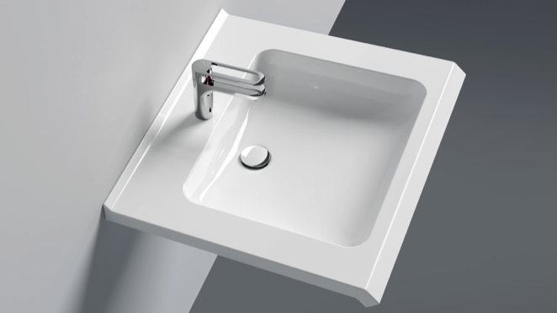
Washbasin with concealed handle edge

