Publisher | Editors

HEWI
Marketing + Innovation

HEWI Heinrich Wilke GmbH
PO Box 1260
D-34442 Bad Arolsen
Phone: +49 5691 82-0
presse@hewi.de
www.hewi.com

Reprint free of charge - copy requested

Internationalization
HEWI establishes subsidiary in the USA
In the course of internationalisation, HEWI established a subsidiary in the USA in November 2016. The US market offers enormous growth potential for HEWI. Particularly with regard to the topic of accessibility, the market is very well developed, but with stigmatising products.
HEWI offers comprehensive solutions that can be used equally by all people. As the market leader in the barrier-free sector, HEWI impresses with high-quality and design-oriented solutions. The products stand for durability: High-quality materials, their precise workmanship and technical know-how enable lasting quality. HEWI offers decades of experience in the field of plastics technology. HEWI has been manufacturing plastic products in its own factory in Mengeringhausen since 1929 and thus stands for the art of engineering made in Germany. HEWI also pursues its claim to functionality and excellent design in the USA.
Reliable partner
The North American market has been actively cultivated by the HEWI Inc. subsidiary since January 2017. Sales activities are initially focused on the care and healthcare market and the hotel sector. HEWI offers system solutions that comply with the American Accessible Design Act (ADA) standard. In order to establish the products and solutions in the market, HEWI Inc. is relying on the existing, long-standing cooperation with its trading partner Häfele. HEWI's expertise in the area of accessibility as well as the high level of plastics competence, Häfele's specific industry knowledge and experience and the common goal of intelligent solutions and outstanding customer service make the companies perfect partners.

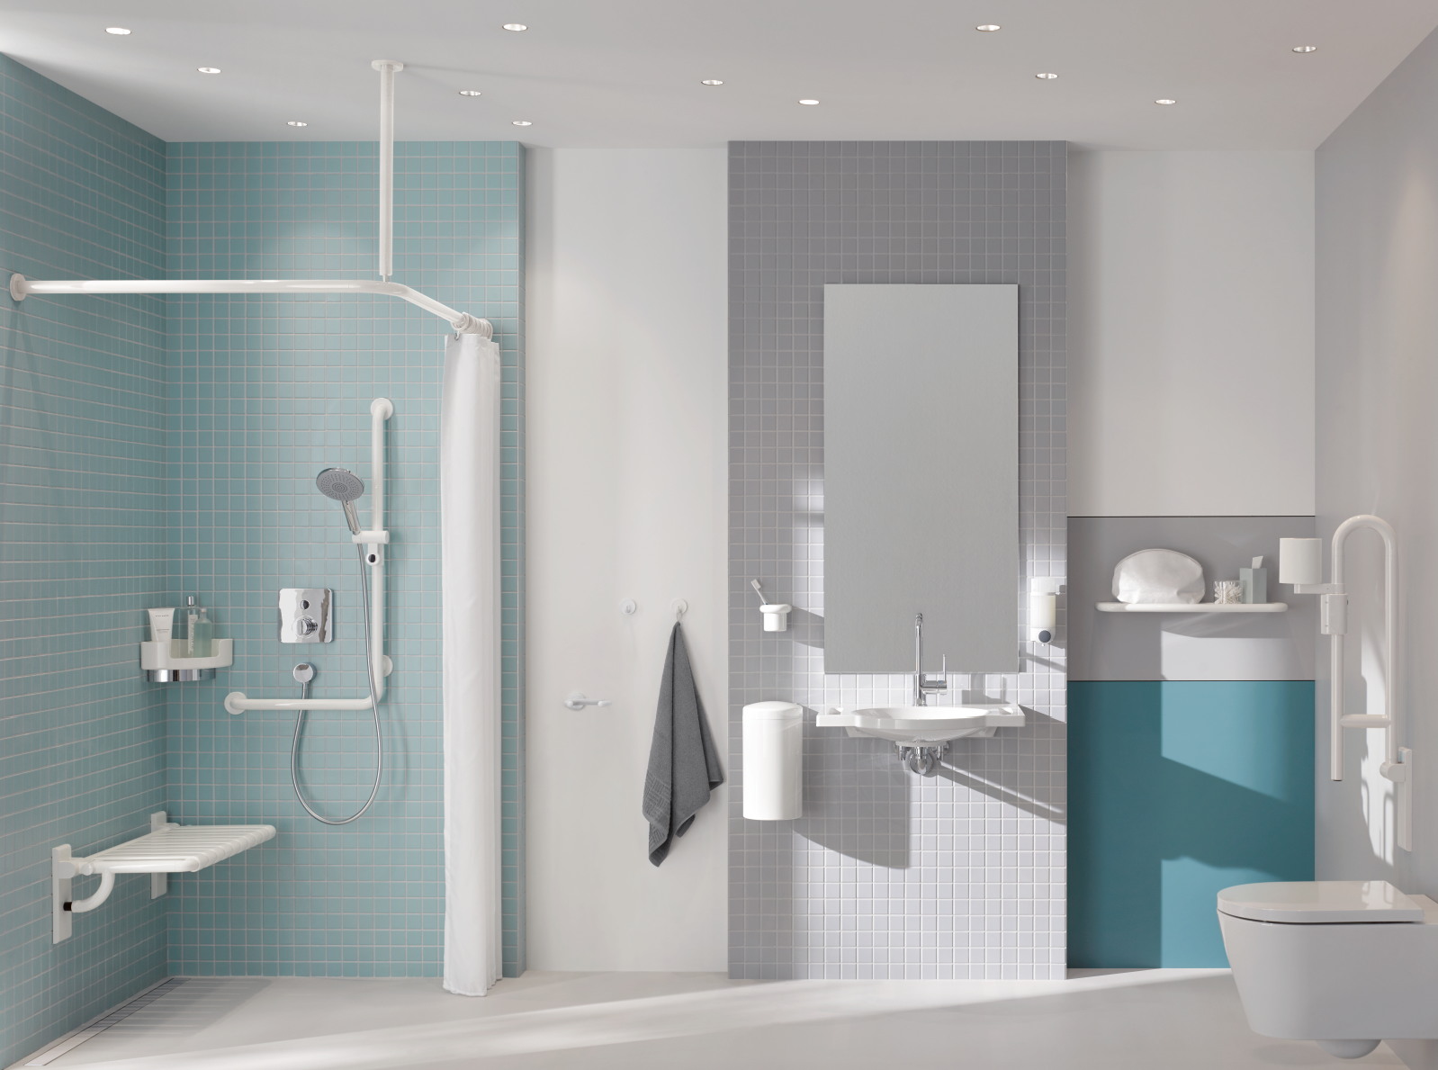

HEWI offers standard-compliant products that can be used by everyone.

For more information, please contact:

HEWI Heinrich Wilke GmbH
PO Box 12 60
D-34442 Bad Arolsen
Phone +49 5691 82-0
Email: presse@hewi.de
Internet: www.hewi.com

