Publisher | Editors

HEWI
Marketing + Innovation

HEWI Heinrich Wilke GmbH
PO Box 1260
D-34442 Bad Arolsen
Phone: +49 5691 82-0
presse@hewi.de
www.hewi.com

Nicolo Martin
Phone: +49 5691 82-106
nmartin@hewi.de

Reprint free of charge - copy requested

HEWI honoured with the Universal Design Award 2020
Meeting the challenges facing society as a whole in a creative way

HEWI was awarded the Universal Design Award "special mention" for the barrier-free classic Series 477/801. In particular, the decades-long commitment to bringing Universal Design to the masses convinced both the end user and the expert jury.

The award honors outstanding products that are future-oriented and can be used across generations. The prize is awarded by the Institute for Universal Design. The Institute for Universal Design has set itself the task of linking business, science and society in a socially responsible context.

Focus on the individual needs of the user
Our society is changing and with it the demands on architecture and product solutions. HEWI has been meeting this challenge for decades and has successfully developed products that always focus on people and their individual needs, without losing sight of aesthetic standards.

Series 477/801 is the answer to the complex requirements of barrier-free bathrooms. The products are well thought-out down to the smallest detail - they convince through lasting quality and hygienic design.

System 477/801 combines purist design with high functionality and a unique depth of range.

Matt surface offers design options
For HEWI, good design also means offering options. Range 477/801 in the matt edition offers a design alternative. The matt edition gives the sanitary room in hospitals, retirement homes or nursing homes a homely design alternative.

Mobile folding support handles offer flexible solutions
New in the range: mobile folding support handles. The innovative solutions offer reliable support and can be used flexibly. If required, the portable folding support handle is simply snapped into the permanently installed mounting plate. If the folding support rail is not required, it can be removed just as easily and the mounting plate covered by a cover cap.

HEWI | Accessibility competence
A clear, geometric design language, high-quality materials, lasting quality and excellent design - this is what HEWI stands for. As the market leader for cross-generational, barrier-free solutions, HEWI sets standards.

HEWI has decades of experience and develops innovative products - for the healthcare sector as well as for public buildings, office and commercial buildings, hotels and the private sector.

Many years of experience and continuous development of the product portfolio in collaboration with architects and users have made HEWI an expert in this field.

Today, the family-owned company based in Bad Arolsen in North Hesse has around 550 employees worldwide. The HEWI production facility - which has now grown to 45,000 m² - is located in the district of Mengeringhausen. The administration is located in the district of Helsen.

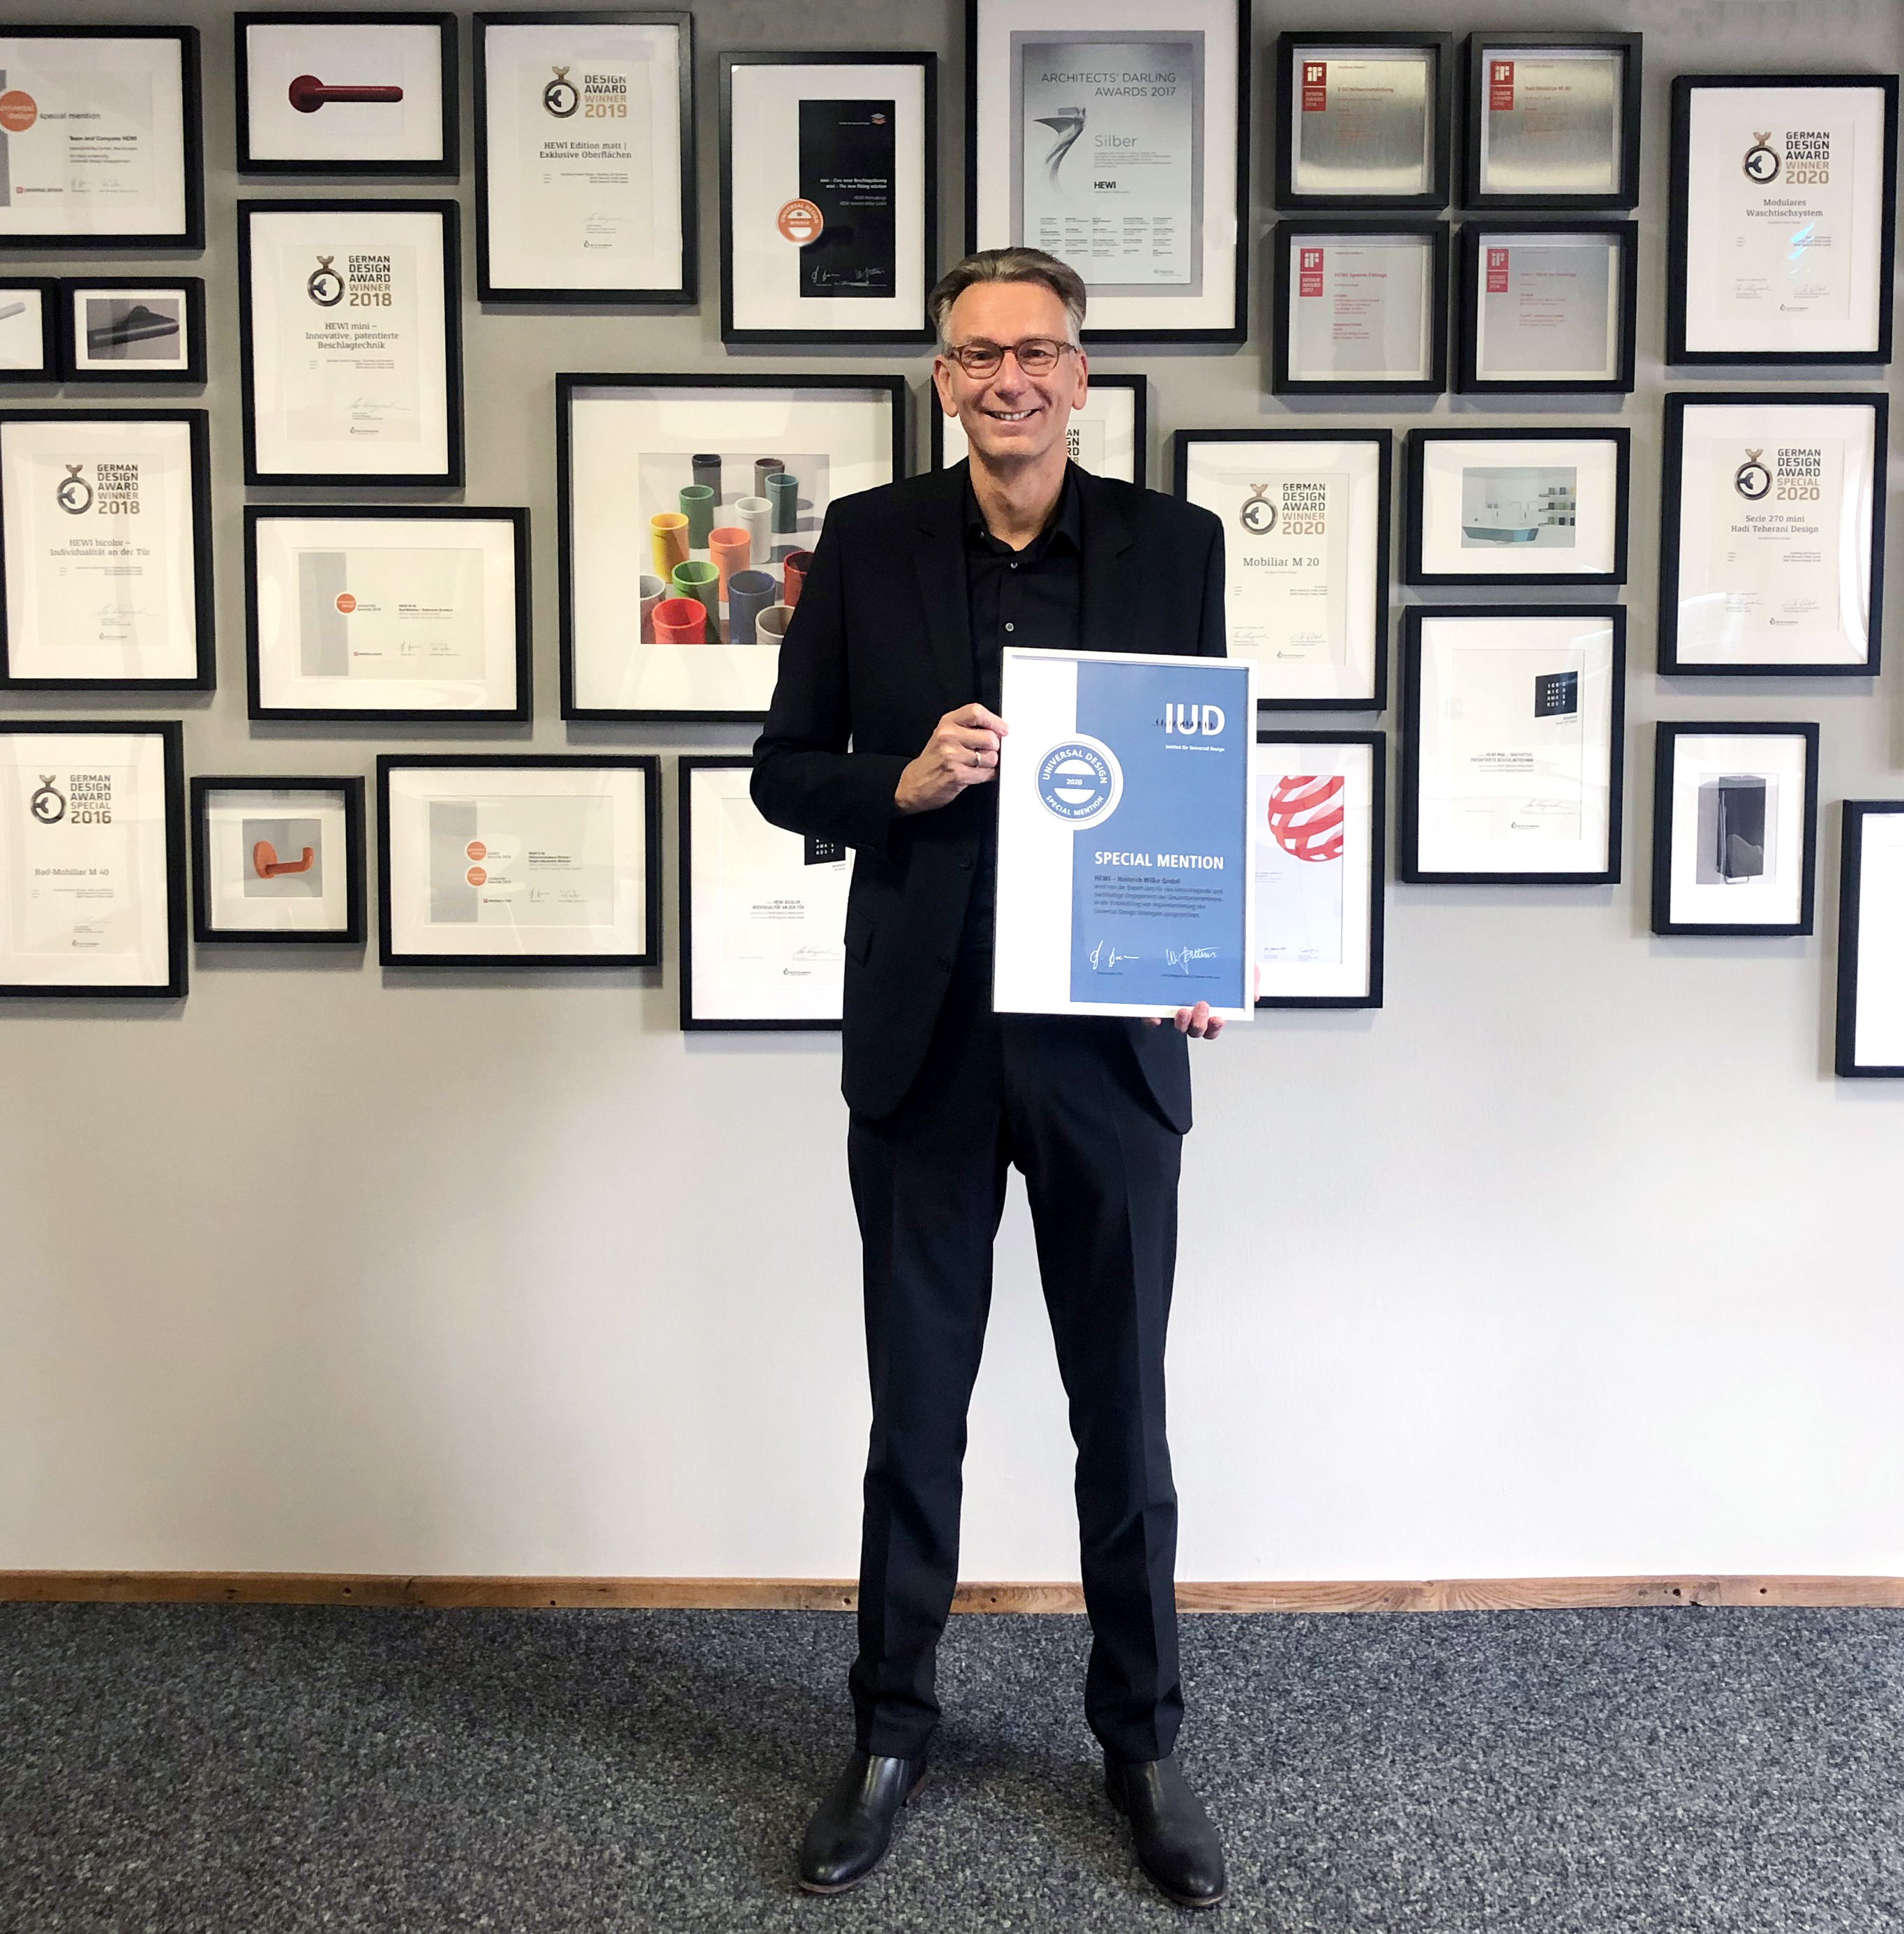

Managing Director Thorsten Stute with the Universal Design Award 2020

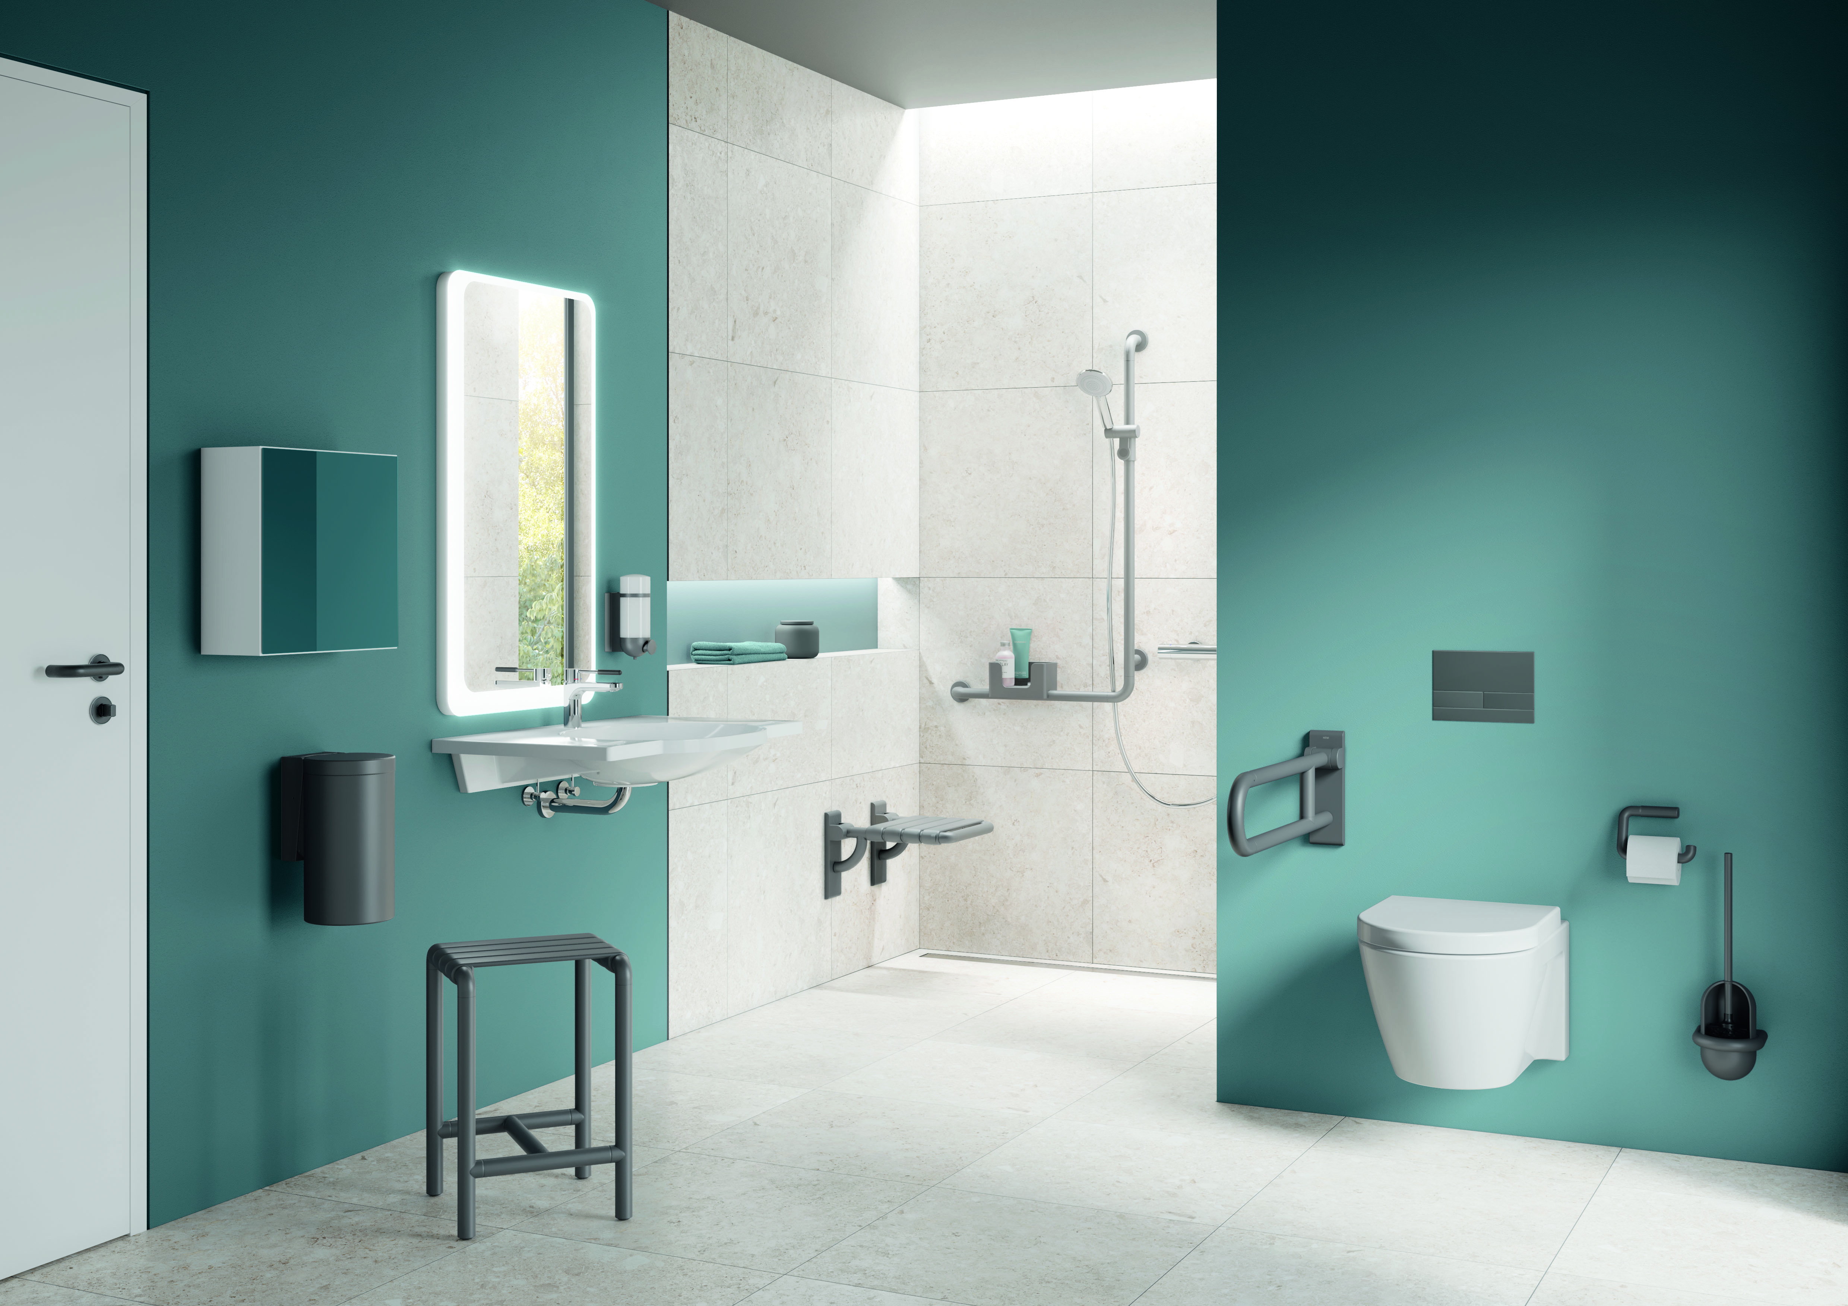

HEWI Range 477/801 in the matt edition

