Publisher | Editors

HEWI
Marketing + Innovation

HEWI Heinrich Wilke GmbH
PO Box 1260
D-34442 Bad Arolsen
Phone: +49 5691 82-0
presse@hewi.de
www.hewi.com

Clara Brenneker
Phone: +49 5691 82-214
cbrenneker@hewi.de

Nicolo Martin
Phone: +49 5691 82-106
nmartin@hewi.de

Reprint free of charge - copy requested

Retirement home Bischofshofen

South of Salzburg, where the Berchtesgaden Alps rise behind the municipality of Bischofshofen, the retirement home stands at the foot of a gently rising slope. The retirement home, planned and implemented by the Salzburg architectural firm Kofler, runs north-south along this elevation. The planners use an innovative barrier-free sanitary system from HEWI here.

Compact architecture with homogeneous facade design

The Bischofshofen retirement home sees itself as a place to be at home. Where people want to live in a harmonious community, the homogeneously designed façade of the building visually takes up the idea with its uniform colour scheme and a regularly designed façade image.

Arrangements of windows and entrances have a chessboard-like effect. Viewed from close up, prominent bay windows set visual accents. They serve the residents as a bright seating area and are designed as a weather-protected balcony replacement.

The narrow building block is designed as an elongated, compact structure and leaves generous space at the front for a leisure area, which was designed as a recreational space according to the guidelines of Far Eastern Feng Shui.

Economy and cost-effectiveness were naturally at the centre of the planning, and with a heating system for pellets the new building set standards in the region in terms of sustainable energy supply.

The extension: expanding the concept to include bright, modern living spaces for today's senior citizens

In 2020, the senior citizens' home expanded its capacities with an extension: 24 nursing rooms for residents and a centre for twelve day guests opened their doors. On the third and fourth floors, 16 rental apartments for assisted living provide a new home.

The barrier-free premises vary between living spaces of 46 to 64 square metres. Each residential unit offers a modern kitchen and is designed to be barrier-free. In total, the retirement home now offers a living space of 1116 square meters. The new building continues the concept of sustainable energy generation, which was already introduced in the first building, with a photovoltaic system on the roof.

The new building was completed in a construction period of 18 months. The façade continues the regularity of the homogeneous exterior façade of the old building in lighter tones and blends seamlessly into the overall picture. Clear lines dominate the exterior as well as the interior: This creates visual structure and orientation. The interiors, including the sanitary rooms, take up the bright, clear and visible colour and line design of the exterior and continue it in every room.

Modern sanitary solutions in the barrier-free premises

Hygiene, ease of care and durability are decisive factors when planning and equipping properties in the healthcare sector. In the bathrooms, a modern barrier-free sanitary system from HEWI was selected in the form of System 900 in stainless steel.

Stainless steel has a non-porous and therefore particularly hygienic surface. Minimal care is sufficient to prevent dirt or microorganisms from accumulating.

The sanitary series is complemented by barrier-free washbasins, which have ergonomically shaped handles. Thanks to their flat design, they can be used both standing and sitting. The grab rails are also suitable for hanging towels.

Purposeful and diverse project buildings: the architectural team kofler architects

Since 1987 kofler architects from Salzburg have been implementing a wide variety of projects. From residential buildings to retirement homes and company kindergartens to event spaces or the Hallein district administration, the range of realizations extends. The practicality and efficiency of the buildings are combined with the demands made on homeliness - in the case of retirement and residential buildings - or on transparency and openness - in the case of public office buildings. Individual yet functional, creative yet cost-covering, the buildings present themselves in their respective surroundings, carefully fitted in by the corresponding façade design. Consideration is given both to historical building styles in the immediate surroundings and to natural features such as the Alpine landscape design of the region, to which the building design is constantly adapted both visually and organisationally.

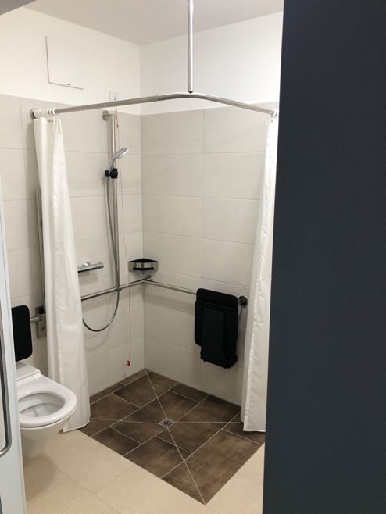

Accessories Series 900

Photographer: HEWI

