Publisher | Editors

HEWI
Marketing + Innovation

HEWI Heinrich Wilke GmbH
PO Box 1260
D-34442 Bad Arolsen
Phone: +49 5691 82-0
presse@hewi.de
www.hewi.com

Reprint free of charge - copy requested

Iconic Awards 2019 | Innovative Architecture
HEWI receives two awards

The international competition of the German Design Council honours the best architecture and design solutions in 2019 with the Iconic Awards, which take a holistic view of the disciplines of architecture, interior, product, communication and concept. HEWI has received the coveted award twice.

Series 270 | ICONIC AWARD 2019 Innovative Architecture - Winner
The new 270 hardware series convinced the jury in the Product category and was awarded the "ICONIC AWARD 2019 Innovative Architecture - Winner".
The 270 series designed by Hadi Teherani is architecture en miniature. The clear lines create an ergonomic shape. Fine details such as the joint between the lever handle and the handle are in perfect balance with the greatly reduced mini rosette.

Modular Washbasin System | ICONIC AWARD 2019 Innovative Architecture - Winner
The modular washbasin system was also convincing in the Product category and was also awarded the "ICONIC AWARD 2019 Innovative Architecture - Winner".
With the new washbasin system, HEWI is continuing the success story of its innovative washbasin family.
Products with important additional functions can be added to the washbasins. The innovative concept allows the integration of an adaptive grab rail, which also serves as a towel rail, and a modular storage system directly on the washbasin. Depending on the need, the washbasin adapts to the changing individual requirements.

Since the competition was founded in 2013, HEWI has received numerous awards in the areas of sanitaryware, fittings and communication.

Iconic Awards 2013 to date:

- 2019: Series 270 and modular washbasin system
- 2018: System 900 and Edition matt
- 2017: mini and bicolor
- 2016: HEWI Website
- 2015: S 50
- 2014: Variable length washbasins
- 2013: System 100

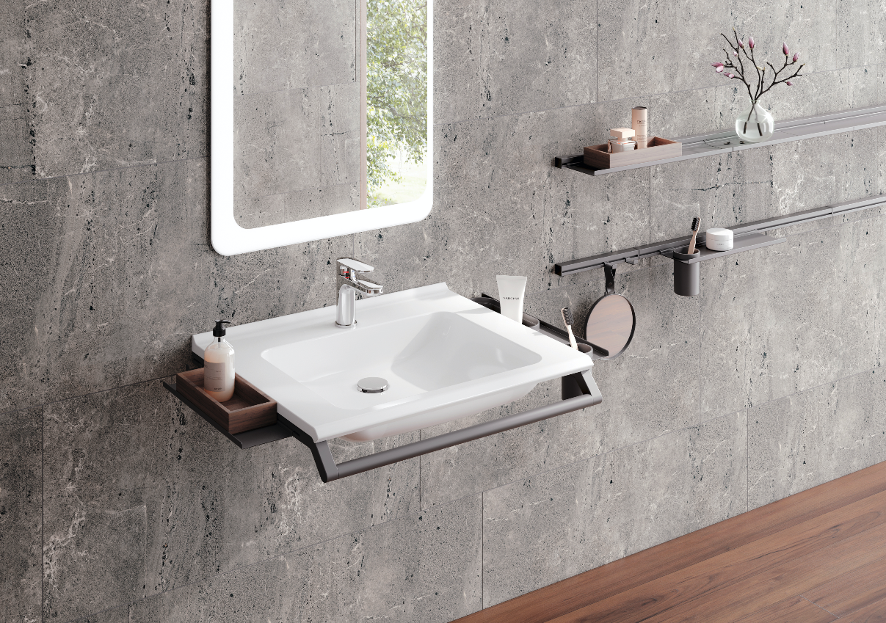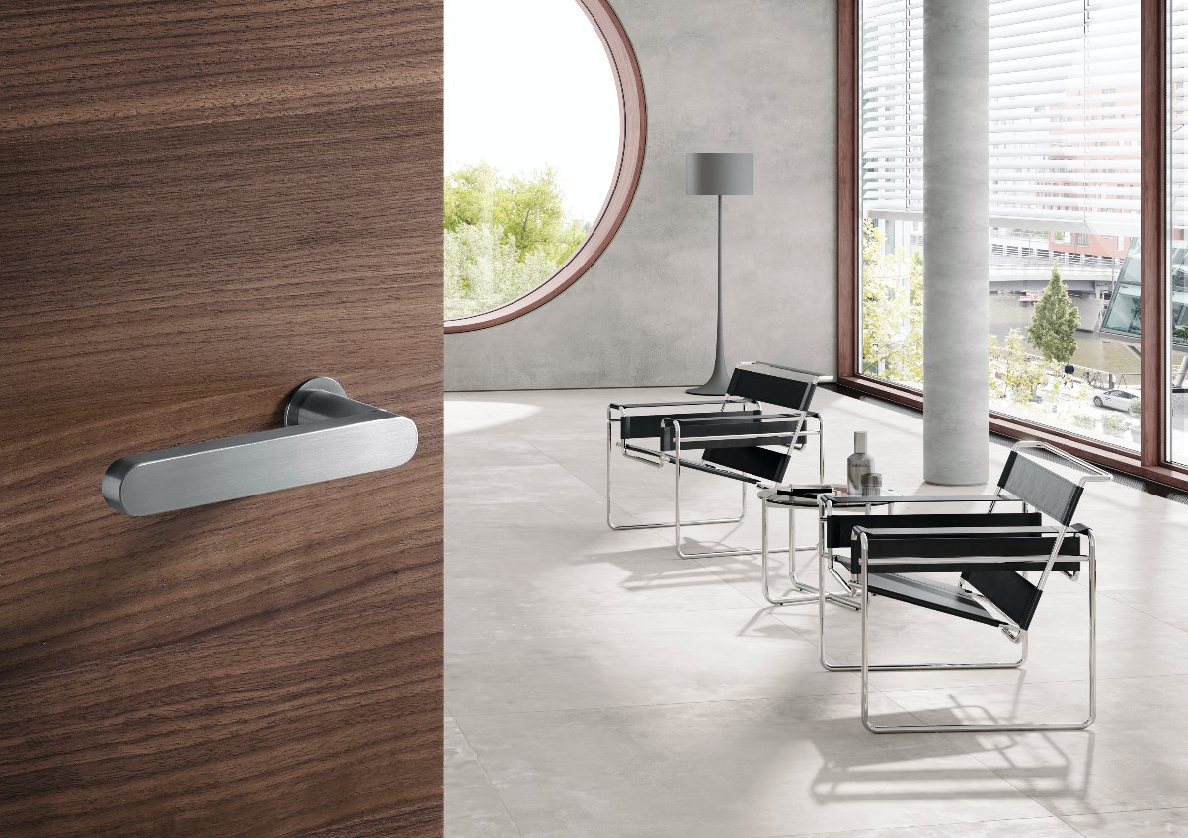
Modular washbasin systemSeries 270

