Publisher | Editors

HEWI
Marketing + Innovation

HEWI Heinrich Wilke GmbH
PO Box 1260
D-34442 Bad Arolsen
Phone: +49 5691 82-0
presse@hewi.de
www.hewi.com

Clara Brenneker
Phone: +49 5691 82-214
cbrenneker@hewi.de

Nicolo Martin
Phone: +49 5691 82-106
nmartin@hewi.de

Reprint free of charge - copy requested

Clinic Dr. Decker shows: Sanitary solutions can be aesthetic and functional

At Clinic Dr. Decker, you will discover how architect Sabine Lenz-Hefele used the System 111 lever handle and solutions from the 477/801 sanitary series to create a continuous design in matt black. The result: a homely atmosphere in the patient rooms.

Project description

Schwabing, located in the north of Munich, was once the district of bohemians and artists. Imposing Art Nouveau villas still characterize the picturesque streetscape today. The plaques on the buildings take the mind back to the time when artists and literary figures such as Paul Klee, Thomas Mann, Rainer Maria Rilke and Wassily Kandinsky lived and worked in the district.

The Clinic Dr. Decker is located in a listed Art Nouveau villa in the heart of the city district in the immediate vicinity of the English Garden. Founded in 1896, the clinic looks back on a history of over 120 years and is now managed by the fourth generation in the family tradition.
Trendy sanitary solutions in historic rooms

During the renovation and modernisation measures, the focus was on the feel-good factor of the patients. Therefore, trendy sanitary solutions have enriched the historic rooms since the renovation.

In keeping with the Healing Architecture approach, Range 477/801 in matt finish brings a homely feel-good atmosphere to the traditional clinic. In combination with lever handle 111 in the matt edition, a continuous design is created - from the door to the bathroom.
Patients and guests alike feel at home in the Clinic Dr. Decker.

The velvety-matt design objects have created inviting and timeless sanitary rooms that support the patient in healing. Because of the pleasant personal atmosphere and the aesthetic design, the patient feels like a guest in the Clinic Dr. Decker.

The Clinic Dr. Decker implements its demand for hygiene, safety and an appealing ambience with the sanitary solutions of the 477/801 series in a matt look. The concept stands for a development in healthcare buildings that is not only strongly oriented towards the well-being of the patient, but actually sees him as a guest.

HEWI washbasins with integrated accessibility are particularly useful. The shallow washbasin can be wheeled under and practical grab rails provide reliable support. These can also be used as towel rails.

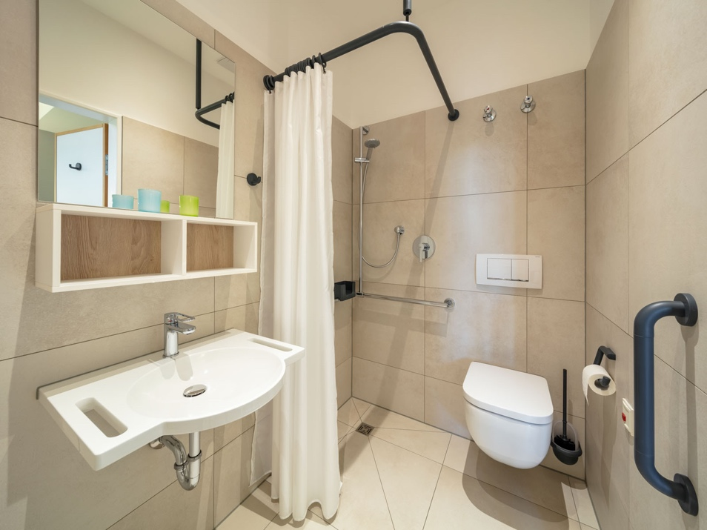

Series 477/ 801 in black matt

Photographer: Thomas Ott

