Publisher | Editors

HEWI
Marketing + Innovation

HEWI Heinrich Wilke GmbH
PO Box 1260
D-34442 Bad Arolsen
Phone: +49 5691 82-0
presse@hewi.de
www.hewi.com

Clara Brenneker
Phone: +49 5691 82-214
cbrenneker@hewi.de

Nicolo Martin
Phone: +49 5691 82-106
nmartin@hewi.de

Reprint free of charge - copy requested

Best of Decade - HEWI as Universal Design Company
2021 awarded

HEWI was awarded the "Best of Decade Universal Design Company 2021" signet. HEWI is therefore one of the best companies of the last ten years which has had a significant influence on universal design and is now entitled to use the "Best of Decade" signet without restriction. The 477/801 series was awarded as a representative of HEWI products, which still inspires users with their individual requirements, for example with new surfaces.
The award-winning range and HEWI already received the Universal Design Award "special mention" in 2020 for their sustained commitment to bringing Universal Design to the wider world.

The Best of Decade Universal Design Company 2021 award honors universal design companies, design firms, and universities that have had a significant impact on universal design. The award is offered by the Institute for Universal Design, which has set itself the task of linking business, science and society in a socially responsible context. The Universal Design Award is one of the most recognized design competitions in the world and enjoys a high reputation far beyond professional circles.

The barrier-free classic: Series 477/801

With Range 801, HEWI launched the first barrier-free range on the German market and achieved market leadership in the barrier-free sanitary fittings segment. In combination with the accessories from Range 477, the most comprehensive barrier-free system solution on the market meets all the requirements for bathroom fittings. Users and care staff were equally in focus during development. With the extension Edition matt, Range 477/801 offers further design options and gives sanitary rooms a homely character. Series 477/801 is available in the matt edition in various shades of white and grey.

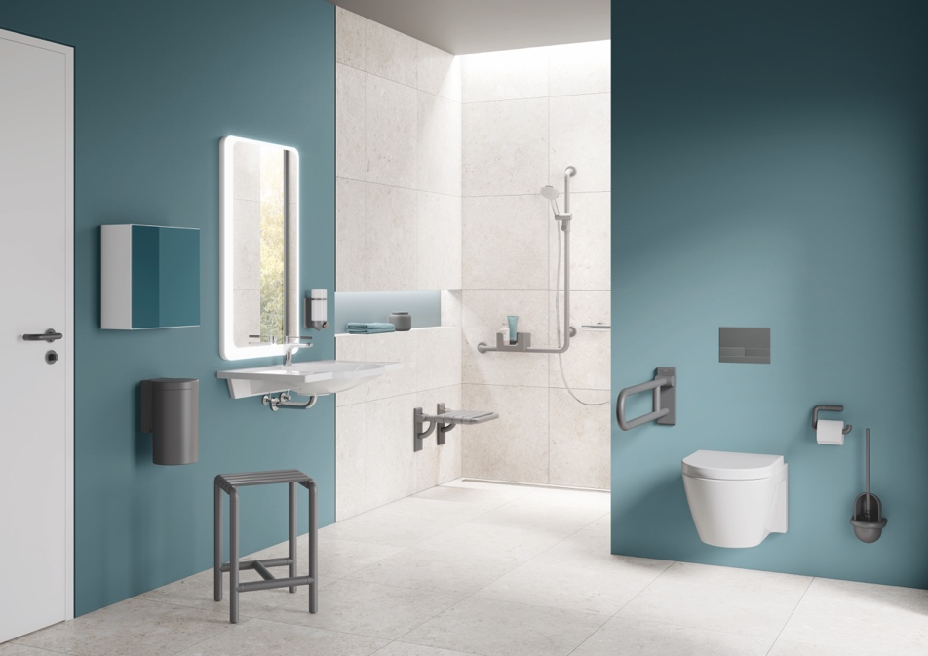

Series 477/ 801 in the matt edition

HEWI is now allowed to use the "Best of Decade" signet without restriction

