Publisher | Editors

HEWI
Marketing + Innovation

HEWI Heinrich Wilke GmbH
PO Box 1260
D-34442 Bad Arolsen
Phone: +49 5691 82-0
presse@hewi.de
www.hewi.com

Clara Brenneker
Phone: +49 5691 82-214
cbrenneker@hewi.de

Nicolo Martin
Phone: +49 5691 82-106
nmartin@hewi.de

Reprint free of charge - copy requested

Flexible equipment
Modular washbasin system
The modular washbasin system from HEWI can be individually configured. The unique concept enables the integration of a grab rail and a modular storage system directly at the washbasin.
The washbasins offer safety and ensure that all bathroom utensils find their place within easy reach. The modular washbasin system from HEWI can be individually configured, easily extended and also dismantled again.

Side trolley
The side trolley offers flexible storage space. It can be conveniently pushed to wherever it is needed. As a design statement, it not only cuts a fine figure in the bathroom, but also creates flexible storage options in the living area. The shelves offer plenty of storage space. The trolley has fixable wheels for a particularly secure stand. The trolley is available with powder-coated surfaces in high-gloss white or matt black with elegant chrome elements.
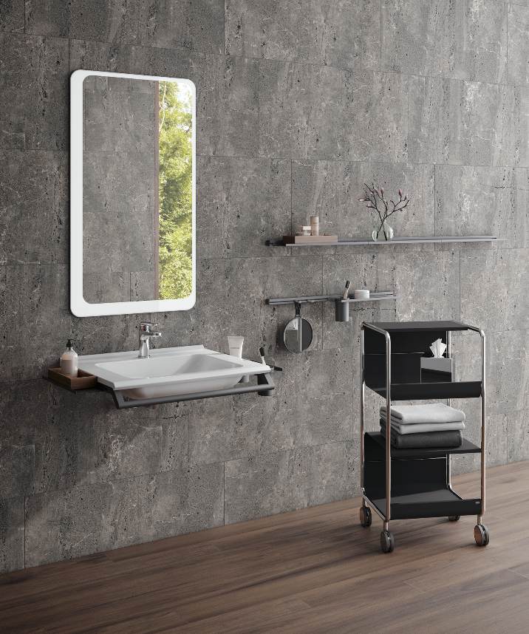

Modular washbasin system and flexibly usable side trolley

HEWI | Home

Safety and a sense of well-being are becoming increasingly important in one's own home. Individual solutions, precisely tailored to people's individual needs, authentic materials and a timeless, reduced product design are becoming increasingly important in planning and furnishing.
HEWI system solutions offer safety and support and, in combination with excellent design, create a feel-good ambience that uniquely combines functionality, comfort and aesthetics.

