Publisher | Editors

HEWI
Marketing + Innovation

HEWI Heinrich Wilke GmbH
PO Box 1260
D-34442 Bad Arolsen
Phone: +49 5691 82-0
presse@hewi.de
www.hewi.com

Clara Brenneker
Phone: +49 5691 82-214
cbrenneker@hewi.de

Nicolo Martin
Phone: +49 5691 82-106
nmartin@hewi.de

Reprint free of charge - copy requested

HEWI honoured with German Design Award 2021

HEWI has received two German Design Awards 2021 "Special Mention" for outstanding design quality: The
new dispenser systems convinced in the category "Excellent Product Design - Public Design" and the HEWI trolley was awarded in the category "Excellent Product Design - Bath and Wellness".

The German Design Award is the international premium prize of the German Design Council. Its goal: to discover, present and award unique design trends.
Every year, top-class submissions from the fields of product and communication design are therefore awarded prizes, all of which are groundbreaking in their own way in the international design landscape. The German Design Award, initiated in 2012, is one of the most recognized design competitions in the world and enjoys a high reputation far beyond professional circles.

The Special Mention award of the German Design Award recognizes a consistent design concept and implementation. Depending on the quality of the submissions, the jury awards an appropriate number per category with this seal of quality for innovative design.
These are selected in each category of the German Design Award by a separate jury of experts.

HEWI dispenser systems

HEWI dispenser systems meet the highest demands in terms of design and functionality. Both manually operated variants and a selection of electronically controlled, touch-free dispensers are available. The wide range of materials for the dispenser systems offers design options.

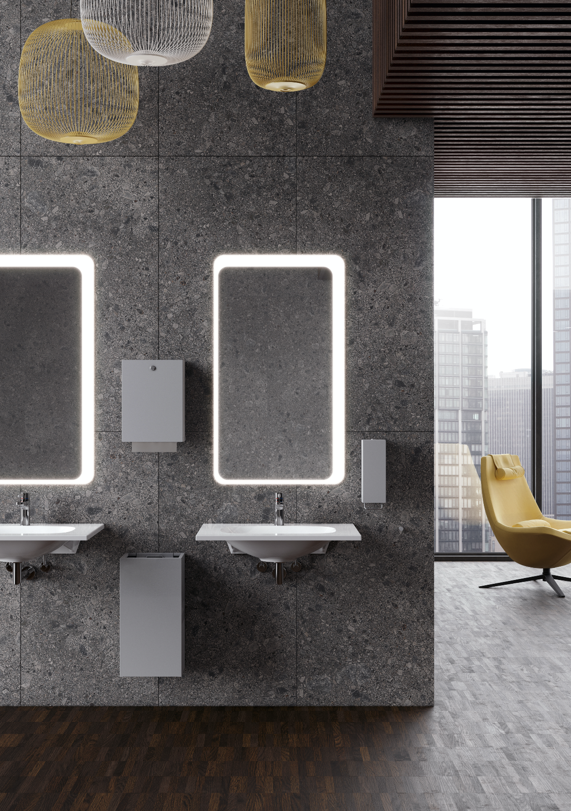
HEWI Dispenser system 900

HEWI side trolley

The side trolley offers flexible storage space. It can be conveniently pushed to wherever it is needed. As a design statement, it not only cuts a fine figure in the bathroom, but also creates flexible storage options in the living area. The shelves offer plenty of storage space. The trolley has fixable wheels for a particularly secure stand. The trolley is available with powder-coated surfaces in high-gloss white or matt black with elegant chrome elements.

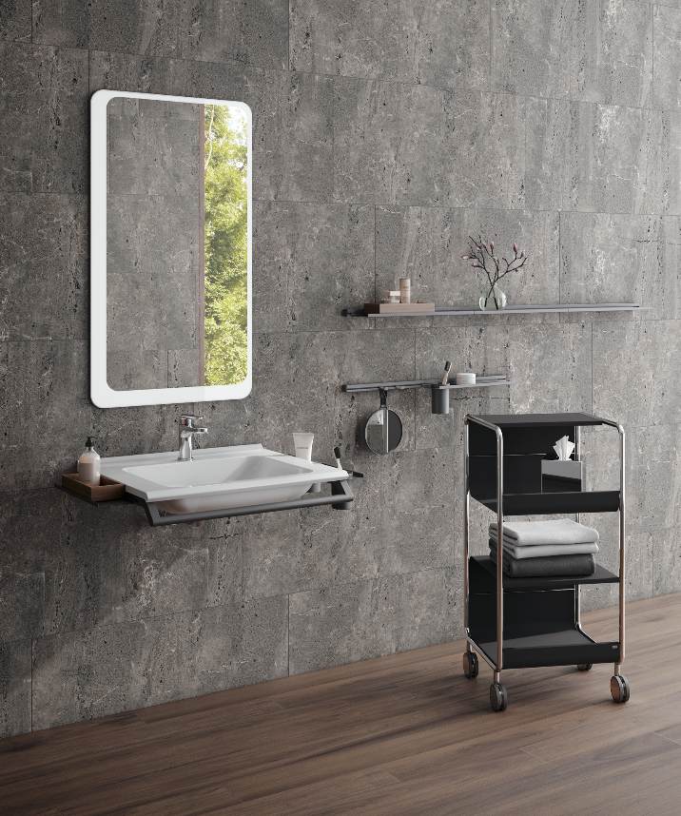

Flexible use side trolley

