Publisher | Editors

HEWI
Marketing + Innovation

HEWI Heinrich Wilke GmbH
PO Box 1260
D-34442 Bad Arolsen
Phone: +49 5691 82-0
presse@hewi.de
www.hewi.com

Clara Brenneker
Phone: +49 5691 82-214
cbrenneker@hewi.de

Nicolo Martin
Phone: +49 5691 82-106
nmartin@hewi.de

Reprint free of charge - copy requested

More hygiene at the door
The importance of the topic of hygiene is becoming increasingly significant in the fields of architecture and construction. Particularly when designing highly frequented buildings and rooms in the public sector, this aspect is increasingly becoming a focus for architects and planners.
One of the most common ways bacteria and viruses are transmitted to humans is through the door handle. Germs get on your hand when you cough and sneeze, and many people leave them on door handles when they touch them.
Especially in highly frequented buildings such as offices, educational and health facilities as well as shopping centres or sports facilities, germs spread rapidly.

For HEWI, design and function are closely linked. This design philosophy is also reflected in solutions and products when it comes to hygiene.
With the sophisticated design of lever handle 115 and a special surface, HEWI enables optimum hygiene at the door.

The lever handle 115 can be easily operated with the elbow due to the clever ergonomic design. The user opens the door through the elbow handle without touching the lever handle with the hand.
The learned look of the handle allows intuitive operation with the elbow when closing and opening doors.

Good to know: The rounded shape of the lever handle is easy to grip even when operated by hand and prevents slipping. The U-shape also prevents clothing from getting caught in passing.

Optimal hygiene due to antimicrobial surface

The lever handle 115 in the active+ variant provides extra hygiene. You don't always have the opportunity to operate a lever handle with your elbow. In this case, the antimicrobial surface of active+ offers additional hygiene at the door.

The active+ process has already been successfully used for years in buildings with strict hygiene requirements such as hospitals and nursing homes. Especially in these facilities, optimal hygiene is important for patients and residents with a weakened immune system.
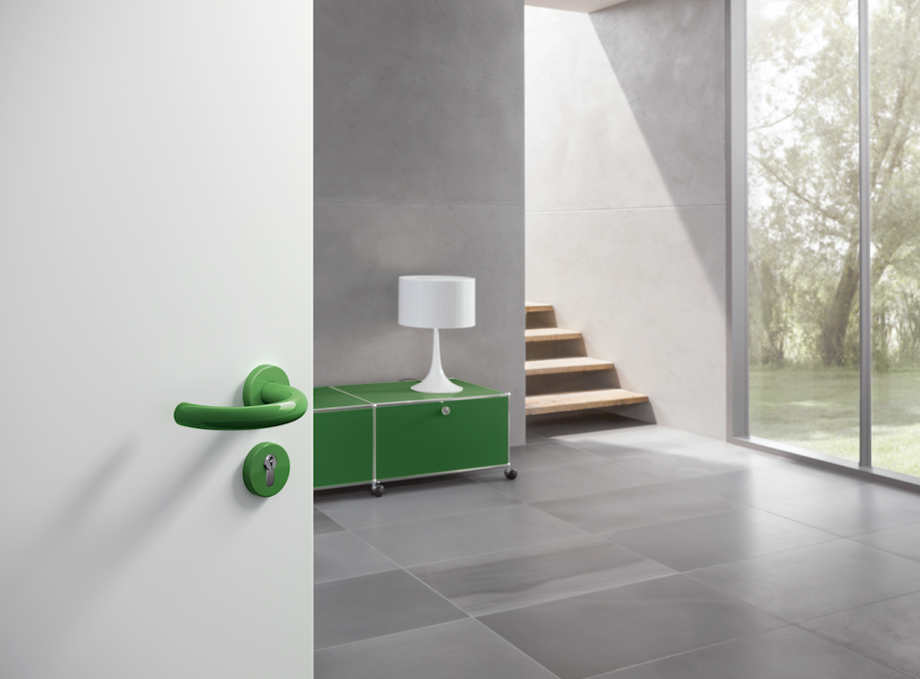
Series 115

