Publisher | Editors

HEWI
Marketing + Innovation

HEWI Heinrich Wilke GmbH
PO Box 1260
D-34442 Bad Arolsen
Phone: +49 5691 82-0
presse@hewi.de
www.hewi.com

Clara Brenneker
Phone: +49 5691 82-214
cbrenneker@hewi.de

Nicolo Martin
Phone: +49 5691 82-106
nmartin@hewi.de

Reprint free of charge - copy requested

HEWI honoured with Iconic Award 2020

The new HEWI dispenser systems convinced the jury of the Iconic Awards 2020. The awards from the German Design Council are regarded as an independent seal of quality of international standing for contemporary developments and design achievements.
A competition for the whole world of architecture: With the ICONIC AWARDS: Innovative Architecture, the German Design Council has been able to establish a neutral, international architecture and design competition that for the first time takes the disciplines into account in their interplay. Awards are given for visionary buildings, innovative products and sustainable communication from all sectors of architecture, construction and real estate as well as the manufacturing industry. The focus is on the holistic staging and interaction of the trades in the context of architecture.

HEWI dispenser systems meet the highest demands in terms of design and functionality. Both manually operated variants and a selection of electronically controlled, touch-free dispensers are available. The wide range of materials for the dispenser systems offers design options.
There is a choice of models with powder coating in black, grey tones and white, as well as stainless steel variants. The dispensers are characterised by their robustness and are perfectly suited for use in heavily frequented sanitary rooms. The majority of the dispensers are available in a sensoric version in addition to manually operated versions. From soap and disinfectant dispensers to paper towel dispensers and waste containers through to hygiene combinations in various sizes, HEWI offers a consistent, functional range that is also characterised by the highest design standards.

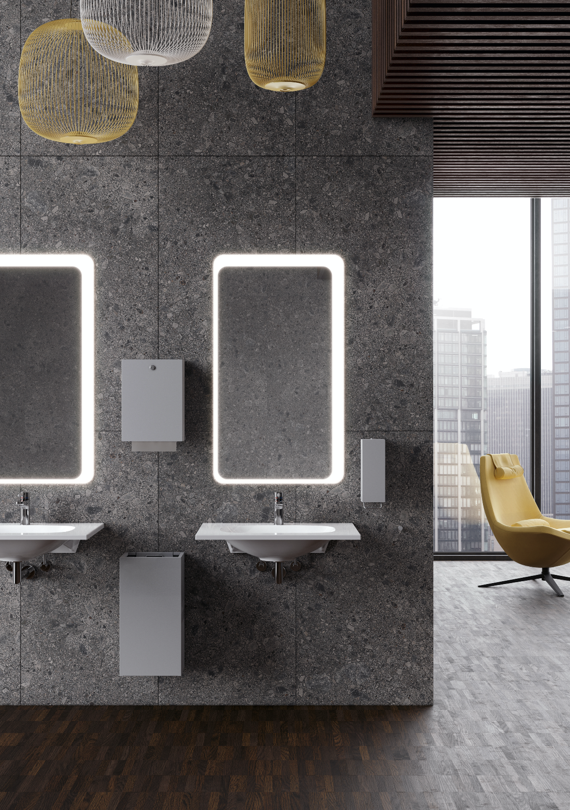
HEWI Dispenser system 900

