Publisher | Editors

HEWI
Marketing + Innovation

HEWI Heinrich Wilke GmbH
PO Box 1260
D-34442 Bad Arolsen
Phone: +49 5691 82-0
Fax: +49 5691 82-319
presse@hewi.de
www.hewi.com

Reprint free of charge - copy requested

Hesse Champions 2018
HEWI honoured as world market leader

At the 27th Hessian Entrepreneur Day of the Federation of Hessian Entrepreneur Associations, the "Hessen Champions 2018" were chosen.
The Innovation and Growth Award of the State of Hesse comprises the categories World Market Leader, Job Engine and Innovation. The winners are selected by a jury with representatives from business, politics and the media. Nine out of 61 applicants made it to the finals of the prestigious competition, and four of them received awards.
The standards for the barrier-free design of bathrooms in public facilities, such as hotels and hospitals, are highly diverse. HEWI was able to convince the jury in the category of world market leader. As a system provider for barrier-free solutions, HEWI has been setting standards for decades and successfully tackles the complexity of national and international requirements with innovations such as System 900.
With the "Hessen Champions", the Ministry of Economics, the Federation of Hessian Business Associations and the Mittelständische Beteiligungsgesellschaft Hessen honour special entrepreneurial successes. Minister President Volker Bouffier, Minister of Economics Tarek Al-Wazir and VhU President Wolf Matthias Mang honoured the winners in front of more than 1,000 guests at the Kurhaus in Wiesbaden.

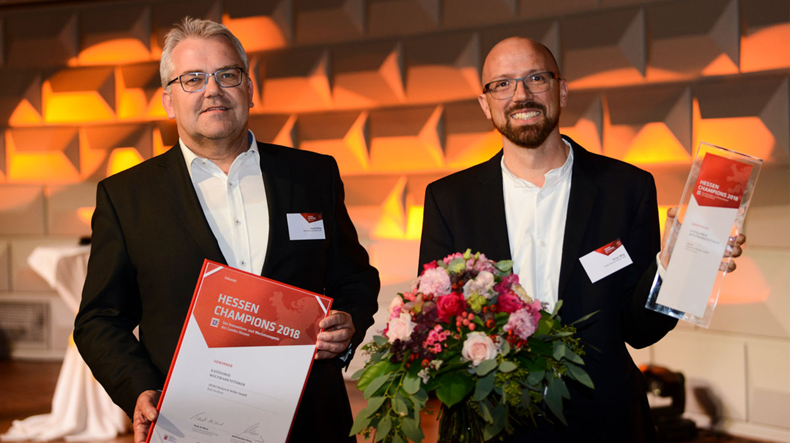
HEWI is "Hessen Champion 2018" in the category World Market Leader.
Image: Sabrina Feige, Client: HessenAgentur GmbH

